PHOTOGRAPHY TIPS

Strong, compelling photos help to convey your story. When it is not an option to use a professional photographer, use these tips and advice to improve your own photography and learn what types of images we’re seeking for use in university communications.

Provisions for Submitting Photos for Inclusion in Rutgers Today

Photos for Rutgers Today to be used in stories and as thumbnail images for the newsletter and website should demonstrate what the story is about. For research stories, these images don’t necessarily have to feature the researcher. Main images of a person are generally only used for profiles. Avoid research graphics as thumbnails when possible.

- Provide high resolution jpeg images
  - Recommended size of 5 x 7 inches (2100 x 1500 pixels at 300 dpi)
- Provide the photographer’s name and contact information.
  - Include copies of usage rights agreements if applicable
- Provide subject, date, and location.
  - Provide the name(s) and contact information for all subjects appearing in the photo.
- Include copies (scans are recommended) of the completed photo model release or HIPAA authorization forms for all subjects appearing in the photo.
  - One form is specifically for minors and must be completed by a parent or guardian.
  - communications.rutgers.edu/resources/photovideo-model-permission-forms-and-hipaa-authorizations
  - For public events, releases are not required.
- Enhancing the technical quality of a photograph is acceptable (getting rid of red-eye, reducing shadow, etc.), but changing the meaning of a photo is not. Alteration of a photo that misleads, confuses, or otherwise misrepresents its accuracy is not allowed.
- Email to andrea.alexander@rutgers.edu

General Tips for Taking Your Own Photos

- Set your camera on highest/resolution quality setting to ensure the best images for print and digital.
- In low-light situations make sure the flash is turned on to avoid grainy or blurry images, but remember the flash will not help to light your subject from a far distance.
- Compose your photograph so that your reason for taking the picture is clearly evident.
- Don’t shoot toward windows or other brightly lit backgrounds unless you want your subject silhouetted.
- Avoid cluttered or complex backgrounds.
- Don’t cut off hands, feet, and tops of heads in photos. Images can be cropped later if needed.
- Avoid mergers such as a tree seeming to grow from a subject’s head.
- Clothing and props
  - Avoid clothing with logos of other universities, offensive material, or brands.
  - Avoid all white or all black clothing.
  - Avoid busy patterns, florals, or stripes.
  - Encourage subjects to wear Rutgers attire and/or add a Rutgers prop (e.g., mug, publication, sign) to your image setting.
  - Encourage subjects to bring an extra jacket, sweater, or tie(s) to change out for variety.
- Bring a comb, mirror, tissues, and oil blotting tissues for hair and skin touch ups.

Taking Good Pictures with Your Smartphone

- Clean the lens. Just give it a good wipe with a clean cloth.
- Set your phone to its highest picture quality and resolution.

Use HDR mode. HDR, or High Dynamic Range, is a staple feature for smartphone camera apps. It brings detail out of the darkest and lightest parts of your picture and creates a better balance of colors overall. The downside is that, in HDR mode, photos take a little longer to process while your smartphone works all this out.

Adjust focus and exposure. If manual focus is available, it's usually activated with a tap on the screen, on the point where you want the camera to focus.

Turn off picture frames. A normally great shot may be ruined by a cheesy frame or background.

Turn off the date stamp.
- Turn off any other effects. These include black-and-white, sepia tones, inverted colors, and so on.
- Avoid subjects in low light, at least if you want them to be consistently lit. The small sensors in camera phones cannot run at high ISO speeds (i.e. high sensitivity to light, permitting indoor photos without a flash) without introducing large amounts of noise (pixilation).
- If you must shoot indoors avoid fluorescent lighting. It can cast a green tint on your subjects.
- Avoid bright reflections, and other "hot-spots.” This will either force the camera to underexpose the rest of the shot, or cause the camera to blow out the highlights on the brightest parts of the shot.

Steady your shot by using a small tripod made specifically for smartphones.

Smartphone cameras are very sensitive to movement. Minimize camera shake to avoid blurry images.
  - Make sure your camera is stable in low light. Smartphone cameras slow the shutter speed in low light, and this can capture any movement you make and blur your photo.
- Turn on the camera’s gridlines. That superimposes a series of lines on the screen of your smartphone's camera that are based on the “rule of thirds.”

Composing a Photo
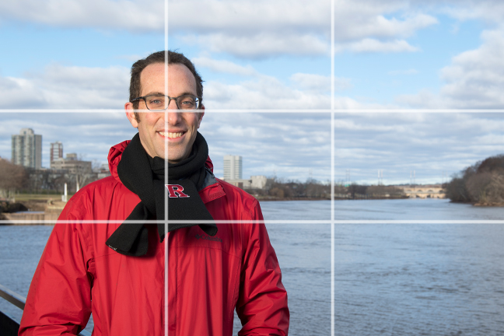

- Keep in mind the universal “rule of thirds,” a photographic composition principle that says an image should be broken down into thirds, both horizontally and vertically, so you have nine parts in total. (Some cameras and smartphones have a gridline option. Turn it on.)
- Avoid centering your subject, which can result in a static, boring photo.
- Place your subject(s) on one of these lines or at an intersection of these lines to take a more dynamic photo. Your photo will be more balanced, level, and visually interesting.

Photographing a Speaker
- People frequently do not look their best while speaking. Try photographing the individual during a pause in speaking. Or do as professional photographers do and take as many shots as possible to try to get that one good image.
- Another trick is to arrive early and take set-up shots of the speaker at the podium prior to the actual event. This way, you can get closer to the subject (5 to 6 feet away), have better control of the photo, and not disrupt the flow of the speaker’s presentation.
- Keep in mind that the flash on your camera is of little use when photographing a speaker from a distance in a large room. The flash will not be sufficient to light the room, so the best strategy is to use available light.

Taking an Individual Portrait
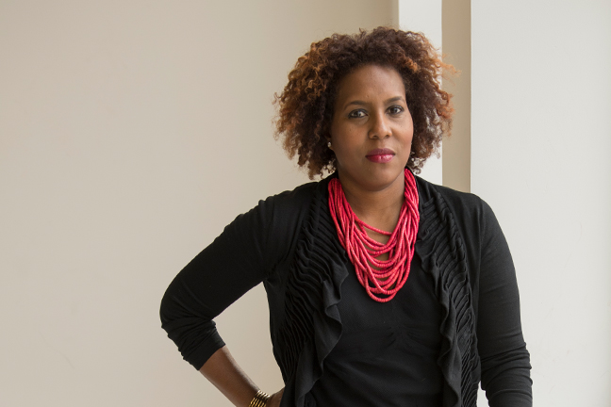
- When shooting indoors, try to use indirect window light. Using the flash may be useful, but remember it can cause red-eye and shadows.
- When shooting outdoors, open shade or an overcast day is best for avoiding shadows. Place the subject in an area with a nondescript, generic background at least 10 feet away from a wall, tree, etc. Be conscious of avoiding lines in the background—poles, lines on a building, utility wires, etc.—that can look like arrows bisecting the subject’s head.

Taking a Group Portrait
- Grip and grin photos and group shots can be less than inspiring. Consider having the subjects do something to tell a story.
- Pose people creatively in a group shot rather than a line up.
- Try to limit the group to three to five people and stand 5 to 6 feet away.
- Try to keep the group at least 10 feet away from a wall or other background.

Photographing in Labs, Clinical Settings, and Clean Rooms
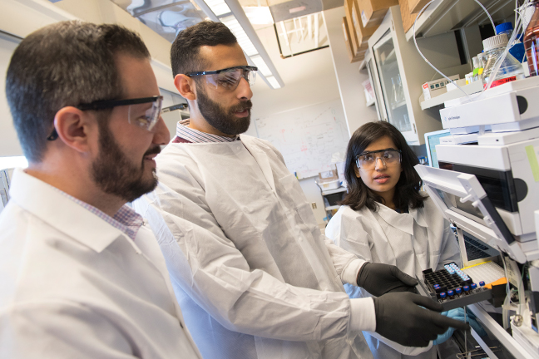
- Safety gear (e.g., safety glasses, gloves, ear protection, etc.) that is required in the lab or clinical setting in which you are photographing should be worn by photo subjects.
- Do not remove safety gear for the sake of a good image.
- Adhere to all protocols and safety requirements of clean rooms, an enclosed space where airborne particulates and contaminants are kept within strict limits.

